DOCUMENTATION

ABSTRACT
This project presents a Student Management System developed using the C programming language to efficiently manage and organize student identification details. The system is designed to store essential student information such as Name, Aadhar Number, APAAR ID, Email ID, and Phone Number in a structured manner using arrays and structures.
The application provides a menu-driven interface that allows users to perform operations like adding new student records, displaying all stored records, and searching for a specific student using the Aadhar number. This project demonstrates the practical use of structured programming concepts, including data structures, string manipulation, loops, and conditional statements. It serves as a basic yet effective solution for managing student data and can be further enhanced with advanced features such as file handling and data validation.
INTRODUCTION
In today’s digital era, managing student information efficiently is a crucial requirement for educational institutions. Student data such as Aadhar number, APAAR ID, email address, and phone number must be stored and accessed accurately for academic and administrative purposes. Manual record keeping is time-consuming, error-prone, and difficult to maintain, especially as the number of students increases.
This project, Student Aadhar, APAAR ID, Email, and Phone Number Management System, is developed using the C programming language to provide a simple and organized solution for managing student records. The system makes use of structures and arrays to store multiple student details and offers a menu-driven interface that enables users to interact with the program easily.
The application allows users to add new student records, display all stored records, and search for a student using the Aadhar number, ensuring quick access to required information. This project helps in understanding fundamental programming concepts such as structured data handling, string operations, loops, and conditional statements. It also demonstrates how C programming can be applied to solve real-world data management problems in a systematic and efficient manner.
SOFTWARE REQUIREMENTS
In today’s digital era, managing student information efficiently is a crucial requirement for educational institutions. Student data such as Aadhar number, APAAR ID, email address, and phone number must be stored and accessed accurately for academic and administrative purposes. Manual record keeping is time-consuming, error-prone, and difficult to maintain, especially as the number of students increases.
This project, Student Aadhar, APAAR ID, Email, and Phone Number Management System, is developed using the C programming language to provide a simple and organized solution for managing student records. The system makes use of structures and arrays to store multiple student details and offers a menu-driven interface that enables users to interact with the program easily.
The application allows users to add new student records, display all stored records, and search for a student using the Aadhar number, ensuring quick access to required information. This project helps in understanding fundamental programming concepts such as structured data handling, string operations, loops, and conditional statements. It also demonstrates how C programming can be applied to solve real-world data management problems in a systematic and efficient manner.
HARDWARE REQUIREMENTS
The following hardware components are required to run the Student Management System efficiently:
- Processor: Intel or AMD processor
- RAM: Minimum 2 GB
- Hard Disk: At least 500 MB of free storage space
- Input Devices: Keyboard
- Output Devices: Monitor

These hardware requirements are sufficient to compile and execute the program smoothly on a personal computer.
CODE
#include <stdio.h>
#include <string.h>

struct Student {
char name[50];
char aadhar[20];
char apaar[20];
char email[50];
char phone[15];
};

int main() {
struct Student s[100];
int choice, count = 0;
char searchAadhar[20];

while (1) {
printf("\n====== Student Management System ======\n");
printf("1. Add Student Details\n");
printf("2. Display All Students\n");
printf("3. Search Student by Aadhar\n");
printf("4. Exit\n");
printf("Enter your choice: ");
scanf("%d", &choice);
getchar(); // Clear buffer

switch (choice) {
case 1:
printf("\nEnter Student Name: ");
fgets(s[count].name, sizeof(s[count].name), stdin);

printf("Enter Aadhar Number: ");
fgets(s[count].aadhar, sizeof(s[count].aadhar), stdin);

printf("Enter APAAR ID: ");
fgets(s[count].apaar, sizeof(s[count].apaar), stdin);

printf("Enter Email: ");
fgets(s[count].email, sizeof(s[count].email), stdin);

printf("Enter Phone Number: ");
fgets(s[count].phone, sizeof(s[count].phone), stdin);

count++;
printf("Student Added Successfully!\n");
break;

case 2:
if (count == 0) {
printf("No student records available.\n");
} else {
printf("\n----- Student Records -----\n");
for (int i = 0; i < count; i++) {
printf("\nStudent %d:\n", i + 1);
printf("Name : %s", s[i].name);
printf("Aadhar : %s", s[i].aadhar);
printf("APAAR ID : %s", s[i].apaar);
printf("Email : %s", s[i].email);
printf("Phone : %s", s[i].phone);
}
}
break;

case 3:
printf("Enter Aadhar Number to search: ");
fgets(searchAadhar, sizeof(searchAadhar), stdin);

int found = 0;
for (int i = 0; i < count; i++) {
if (strcmp(s[i].aadhar, searchAadhar) == 0) {
printf("\nStudent Found!\n");
printf("Name : %s", s[i].name);
printf("Aadhar : %s", s[i].aadhar);
printf("APAAR ID : %s", s[i].apaar);
printf("Email : %s", s[i].email);
printf("Phone : %s", s[i].phone);
found = 1;
break;
}
}
if (!found) {
printf("No student found with given Aadhar.\n");
}
break;

case 4:
printf("Exiting...\n");
return 0;

default:
printf("Invalid choice! Try again.\n");
}
}
}

RESULT :
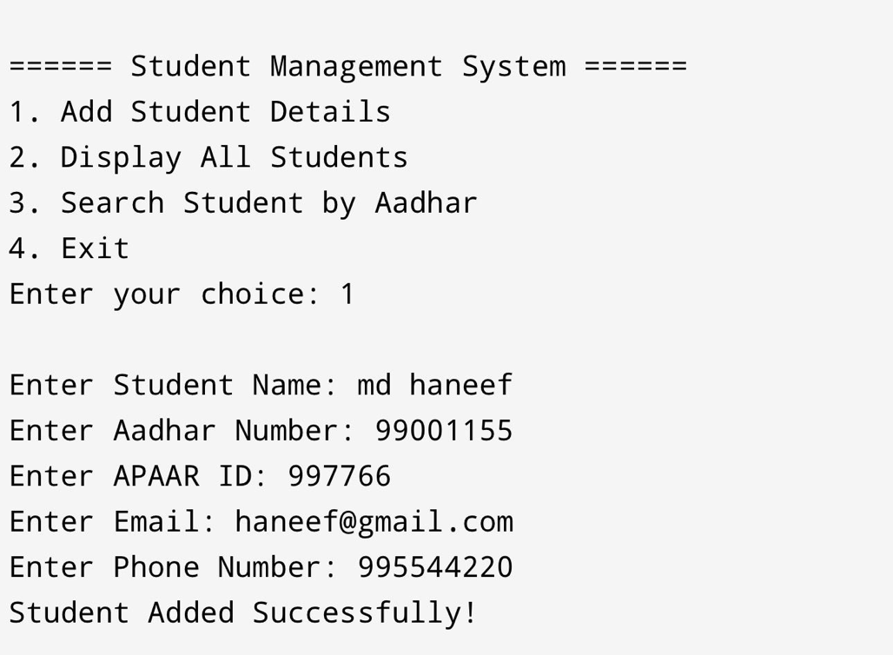
- Add student details
- Display all students
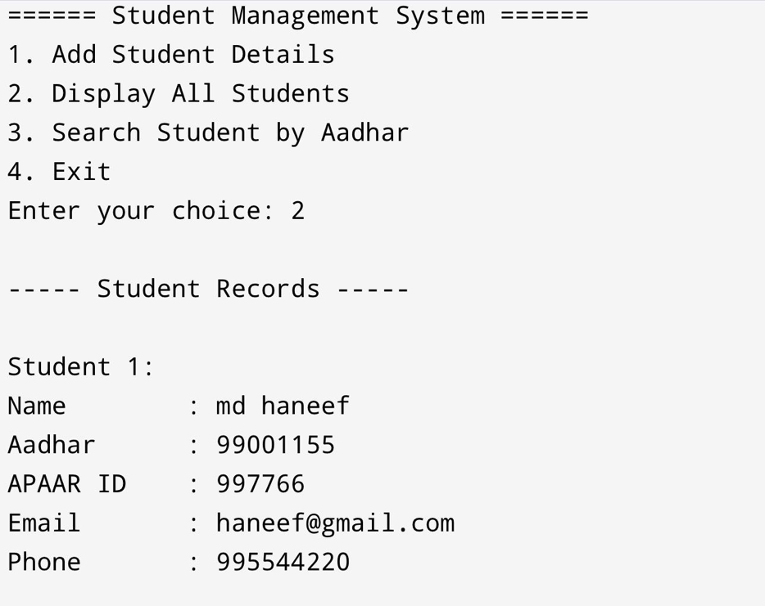
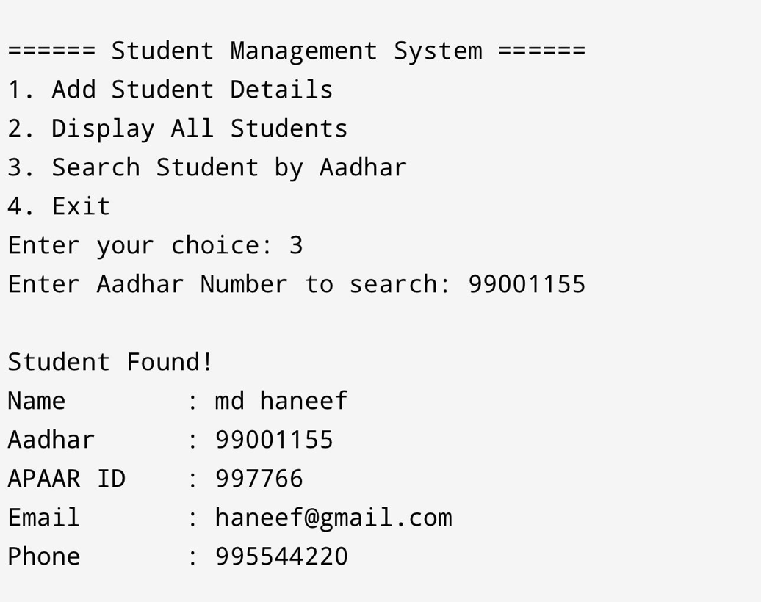
- Search student by aadhar
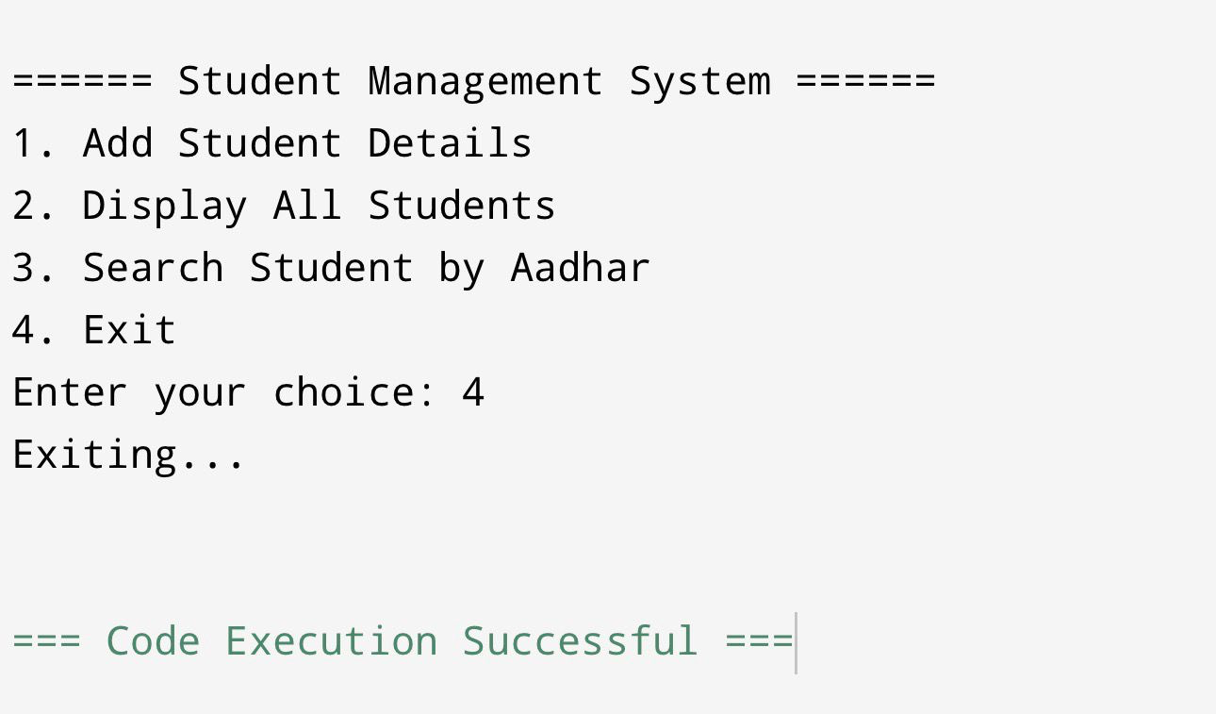
- Exit

CONCLUSION
The Student Aadhar, APAAR ID, Email, and Phone Number Management System was successfully developed using the C programming language and achieved its intended objectives. This project effectively demonstrates how structures and arrays can be used to store and manage multiple student records in an organized and systematic manner. The use of string handling functions ensures accurate processing of textual data such as names, identification numbers, and contact details.

The menu-driven design of the system provides ease of use and allows users to perform essential operations such as adding new student records, viewing stored information, and searching for student details using the Aadhar number. This project helped in strengthening the understanding of core programming concepts including structured programming, loops, conditional statements, and data management techniques.

Overall, the system serves as a basic yet practical application of C programming for student data management. It can be further improved by incorporating advanced features such as file handling for permanent data storage, record updating and deletion options, and input validation to enhance reliability and usability.

